**SLIDE OF PRESENTATION OF THE SUBMISSION THEME : DIAPO**

**International Ocean Colour Coordinating Group** (**IOCCG**)

HIGH SPATIAL AND TEMPORAL RANGE PRODUCTS AND SERVICES FOR THE COLOR OF THE OCEAN (**HIGHROC**)

**THE INTERNATIONAL ASSOCIATION FOR PARTNERSHIP AND EMERGENCE IN AFRICA** **(AIPEA)** **AND**

**THE INTERNATIONAL ASSOCIATION FOR THE POOR INDIDENTS AND ASSISTANCE** **(AIPIA)**

**CONTACT:** **AIPEA** AND **AIPIA**  **ADMINISTRATION**

06 AMBROISE STREET CROIZAT 93200 SAINT DENIS (France)

**PHONE :** 00 33 (0) 9 50 85 90 60 / 00 33 (0) 6 14 05 67 69

**E-mail :** partenariats-emergences [at] hotmail.com [at] = arrobas

**AIPEA** AND **AIPIA** JOINTLY PARTICIPATE IN THE **CONFERENCE SCIENCE HIGHROC** FROM 07 TO 09 NOVEMBER 2017 IN BRUSSELS.

**REPRESENTED BY:**

**Dr. LEBEAU PEMHA THINA:** FOUNDING PRESIDENT **AIPEA**  / **AIPIA** and Researcher on the Scientific Committee for Oceanic Research (SCORE)

SLIDE OF PRESENTATION OF THE SUBMISSION THEME

     - Argos System History

a) Argos System History

     - Earth's Total Heat Content anomaly

- **Spatial observation in addition to "in situ" measures**

**Floats "Argo"**

**a) Ocean: observations made from space**

**-** Conclusion

**SUBMISSION THEME:**

**NEW SCIENTIFIC AND TECHNOLOGICAL ADVANCES (IN SITU MEASUREMENT AND VALIDATION) WITH THE ARGOS SYSTEM IN RELATION TO NEW GENERATION SATELLITES.**

**Argos System History**

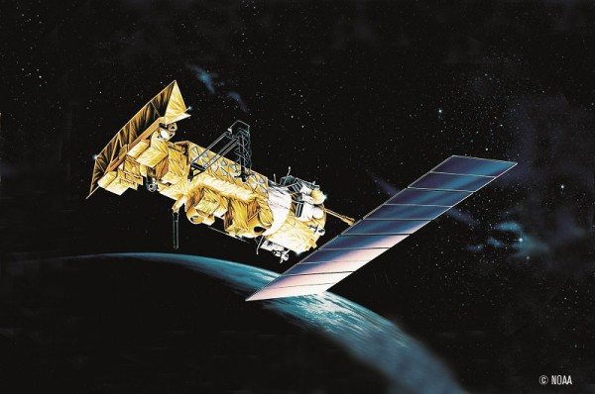

**http://www.argos-system.org/fr/argos/comment-fonctionne-argos/**

**The Argos system was created by:**

• **CNES**, the French space agency **(France)**

• **NOAA**, National Oceanic and Atmospheric Administration **(USA)**

• **NASA**, National Aeronautics and Space Administration **(USA)**

Today, the Argos system is operated, maintained and marketed by the **CLS** group, a subsidiary of **CNES**.

**International Space Agencies**

At present, several other international space agencies are also actively involved in the **Argos** system, including **EUMETSAT** (European Organization for the Exploitation of Meteorological Satellites), **NASDA** (National Space Development Agency of Japan) and **ISRO** (Indian Space Research Organization…)

**Argos** is the only global satellite tracking and data collection system dedicated to studying and protecting the planet's environment.

• 22000 ACTIVE TAGS EVERY MONTH

• 100 COUNTRIES USERS IN THE WORLD AND 8000 ANIMALS FOLLOWED AND LOCATED



Heat balance of the planet Earth since 1950 (Murphy 2009). Data for the ocean come from Domingues et al 2008. "Land + Atmosphere" (Earth + Atmosphere) includes heat used to melt ice.

**Spatial observation in addition to "in situ" measures**

**Floats "Argo"**



**http://argonautica.jason.oceanobs.com/html/argonautica/tutorial/is_argo_uk.html**

**Ocean: observations made from space**

**Main parameters measured:**

- Surface temperature of the sea **:** **passive microwaves**

- Surface winds **:** **active microwaves (radar / scatterometers)**

- Surface salinity **:** **radiometry**

- Current Ocean Surface Topography, Sea Level Variations **: Spatial Altimetry**

- Height and wave spectrum **:** **spatial altimetry, radar imagery**

- Water color (phytoplankton **>** marine ecosystems): **multispectral imagery**

- Mediate surface of the sea (geoide) : **altimetry, spatial gravimetry**

**http://eoimages.gsfc.nasa.gov/images/imagerecords/78000/78250/salinity_aqu_201109-201205.h264.mov**

**http://aquarius.nasa.gov/overview-mission.html**

**Ocean surface salinity is related to the water cycle (evaporation and precipitation)**

**The principle of altimetry: © CNES**



**http://ocean.cls.fr/html/cash/presentation/altimetry_fr.**

SATELLITE D'ALTITUDE >>>> = **ALTITUDESATELLIT** TOPOGRAPHIE DYNAMIQUE >>>> = **DYNAMIC TOPOGRAPHY**

NONOSPHERE >>>> = **NONOSPHERE**

ALTIMETRIQUE DISTANCE >>>> = **ALTIMETRIC DISTANCE**

NIVEAU DE LA MER >>>> = **SEA LEVEL**

LASER STATION >>>> = **LASER STATION**

ELIPSOIDE DE REFERENCE>>>> = **ELIPSOIDE REFERENCE**

GEOIDE >>>> = **GEOIDE**

**CONCLUSIONS**:

**ARGOS TRANSMITTING BEACONS**

**OVERVIEW** RECEPTION STATION

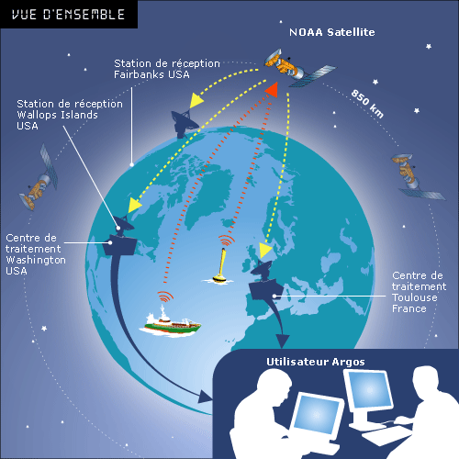

TREATMENT CENTER **USERS Argos**

**The localization system: how does it work?**

The beacons send a signal at regular intervals to the satellites.

Satellites collect data (**signal = GPS position + pre-coded messages + technical monitoring**). The satellites flying over the area,

Retransmit in real time to Direct Reception stations.

The receiving stations relay the signal between the satellites and the processing centers. For Argos, more than 50 terrestrial receiving antennas are implanted on the Globe. .

Data centers collect all data, process it and distribute it to users.

**CLS** has two redundant data centers: **the first at CLS**

At the headquarters of the company in **Toulouse** and the second in the **USA** near Washington ensuring a continuous operation whatever happens.

Once the data reaches the processing center, the locations are automatically calculated and made available to the users.