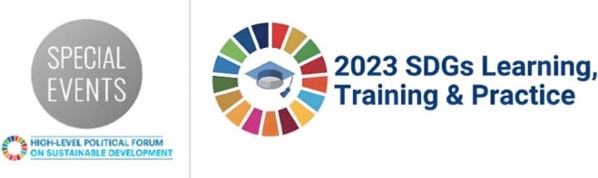
SDGs Learning, Training and Practice 2023
Informal Summary Template
Summary of the SDGs Learning Session #2: Accelerating SDG 6 Implementation: Water Action Agenda and Interlinkages with other SDGs
10 July 2023, 1500 EDT
In Person Session.
Background Information
WASH is central to the achievement of all other SDGs. Access to safely managed WASH services are essential for improved child well-being, health, nutrition, education, and overall outcomes. Simply stated, WASH services that are safe, plentiful, inclusive, and sustained are transformative. Transformative WASH relieves families of concerns about the quality, accessibility, or reliability of services, and leads to flourishing communities.
This session showcased how WASH intersects with Health (SDG 3), Education (SDG 4), Gender Equality (SDG 5), Energy (SDG 7), Climate (SDG 13) and Partnerships (SDG 17). By illuminating linkages between WASH and a number of the other goals, participants were able to see how SDG 6 is a foundational building block and needs to be accounted for no matter which of the 16 other SDGs are being considered. By actively championing SDG 6, we will amplify the urgency and importance of this goal, facilitating its integration into various aspects of sustainable development, and ensuring that water and sanitation become accessible and sustainable for all.
Recording: https://media.un.org/en/asset/k1y/k1y9vy8zjg
Slides:
Main Partners
- World Vision: https://www.wvi.org/high-level-political-forum
- Millennium Child Support Group: https://www.millenniumchildsupport.org/

Short summary of session and key topics discussed:
For each of the SDGs discussed, several key points were brought forward.
- SDG 3 (Health): Clean water and sanitation are a critical aspect for health facilities to ensure a strong health system. We also must remember the WASH needs of slum dwellers to prevent the spread of disease and reduce infections.
- SDG 4 (Education): Latrines at schools must consider menstrual health and hygiene to ensure girls do not miss school because of their period. With proper WASH facilities in place, including separate, safe, and dignified toilets and handwashing stations, we can create an environment that supports the needs of women and girls, ensuring their physical and emotional well-being. Providing water close to the home also means that children do not need to travel long distances to fetch water and can spend more time learning.
- SDG 5 (Gender Equality): WASH programming should strive to not only be sensitive to gender but also be transformative in the way that it addresses the causes of gender-based health inequalities and works to transform harmful gender norms, roles, and relations.
- SDG 7 (Energy): Rural access to both water and electricity are lagging behind access in more urban areas. To increase efficiencies, these should be planned for and funded together, especially in schools and health facilities where the benefits are well articulated.
- SDG 13 (Climate): Groundwater is at risk and must be monitored to ensure sustainability of current water systems. Integrated water resource management (IWRM) should be an important component to all WASH projects.
- SDG 17 (Partnership): We all must work together to achieve SDG 6; it should be everyone’s priority. Rwanda is a great example of Government leading the way to build partnerships to achieve SDG 6. Together, we can make a significant impact and drive positive change.

Key recommendations for action
- SDG 6 should be everyone’s responsibility. But we still need champions to keep it at the forefront of our minds and work to integrate it into other SDG programming.
- Partnership is extremely important. With the government in the lead, civil society, private sector, donors, and community members should come together to have the greatest impact. Support organizations should work towards SDG 6 by mobilizing resources, both financial and non-financial.
- Climate change is showing up in all parts of the globe and is a non-negotiable consideration for SDG 6 programming. Integrated water resource management should be a major pillar for all the work that is carried out.
- WASH in institutions (Health facilities and educational facilities) are essential to consider along with community access and are an on-ramp for addressing energy and gender equality needs.
- By investing in proper WASH infrastructure, we create a foundation for healthier communities, improved access to education, and a more sustainable future.

