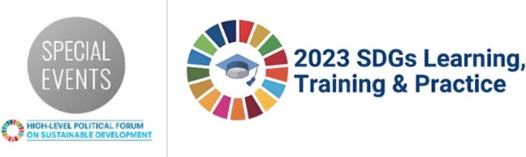
SDGs Learning, Training and Practice 2023
Informal Summary Template
Summary of the SDGs Learning Session: Building Sustainable Cities: Harnessing the Potential of Local Communities to Withstand Crises
12 July 2023 – 15:00 EDT
In-person
Background Information
Building Sustainable Cities: Harnessing the Potential of Local Communities to Withstand Crises
Webcast
Home to more than 55 per cent of the world’s population – a percentage projected to swell to nearly 70 per cent by 2050 – cities are considered engines of economic growth, knowledge generation and innovation. While cities have the potential to propel sustainable development and promote equitable economic growth, they are also at the frontline of multilayered crises, from the recent Covid-19 pandemic to climate change, migration and forced displacement, and conflict.
These multiple crises have not only exacerbated inequalities in cities; but also derailed progress towards achieving sustainable development goals; and, often, worsened pre-existing forms of exclusion.
The focus was on the significant role of urban communities from the Global South in withstanding external shocks. Examples from cities in Africa, Asia, and Latin America showcased how organizations of the urban poor led response and recovery efforts.
The primary objectives of the session were:
- Promote peer learning and exchanging ideas among urban actors for locally-led approaches to resilience-building.
- Share knowledge and best practices for successful recovery in cities.
- Foster collaboration among local authorities, community-based organizations, government agencies, NGOs, and other stakeholders, to achieve equitable and resilient urban development.
Main Partners
- Cities Alliance
- Swiss Agency for Development and Cooperation (SDC)
- Slum Dwellers International (SDI)
- Women in Informal Employment: Globalizing and Organizing WIEGO
- City of Montevideo, Uruguay
- United Cities and Local Governments (UCLG)

Short summary of the session and key topics discussed:
In this learning session at the UN High-level Political Forum on Sustainable Development, Cities Alliance and its partners delved into the local responses to multifaceted crises faced by cities beyond the Covid-19 pandemic, including climate change impacts, violence, food shortages, and governance issues. They emphasized the pivotal role of urban communities, particularly the vulnerable ones, in building resilience and achieving inclusive development. The key focus was on empowering these communities to withstand crises and improve the lives of all residents.
The session highlighted the need to place the urban poor at the heart of recovery efforts to achieve inclusive development and reinforce the 2030 Agenda.
Key topics discussed:
- Cities face various ongoing crises beyond the Covid-19 pandemic, including displacement, climate change impacts, violence, food shortages, pollution, governance issues, access to water, and diseases.
- Urban communities, especially the vulnerable ones, are crucial in building resilience and achieving inclusive development.
- Empowering urban communities to withstand crises and improve residents' lives is essential.
- Placing the urban poor at the centre of recovery efforts is crucial for inclusive development and reinforcing the 2030 Agenda.
- Building partnerships with urban communities enhances inclusivity, resilience, and crisis response in cities.
- Informal workers have innovative solutions for city planning and crisis interventions.
- Partnerships must recognize and value the contributions of the urban poor, such as street vendors and waste pickers, who play critical roles in food security and recycling services.

Key recommendations for action
- Empower Urban Communities: Place the urban poor at the centre of recovery efforts and empower them to be active participants in decision-making processes. Listen to their perspectives and innovative solutions, as they have valuable insights into their own situations.
- Strengthen Partnerships: Build strong partnerships with urban communities, recognizing the value of informal work and the essential roles played by informal workers like street vendors and waste pickers. These partnerships should be based on trust and inclusivity, harnessing the expertise of informal worker leaders.
- Improve Data Collection: Enhance data collection on informal settlements to gain accurate information about the urban poor's living conditions and needs. This data is crucial for building effective collaborations, negotiating with governments, and implementing crisis interventions.
- Prioritize Inclusivity: Prioritize the well-being of all residents in cities, respecting and revitalizing nature, and incorporating principles of solidarity into government systems. This inclusive approach fosters sustainable and equitable urban development.
- Elevate City Voices: Advocate for the voices of cities to be heard at national, regional, and global platforms to address crises effectively and influence international solutions. Cities should be recognized as pivotal actors in delivering solutions and achieving the Sustainable Development Goals.

