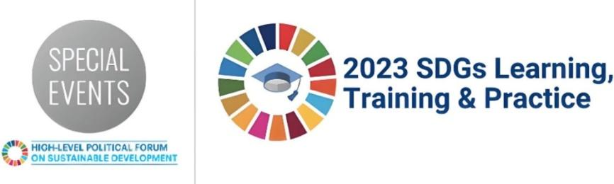
SDGs Learning, Training and Practice 2023
Summary of the SDGs Learning Session: Session 7 – Accelerating resilient recovery: Role of Infrastructure Sector and Entrepreneurship
13 July 2023, 08:30 EDT
Virtual Session
Background Information
In the Session 7: Accelerating Resilient Recovery: Role of Infrastructure Sector and Entrepreneurship, the experts from the UN-Habitat, UNCTAD, the International Anti-Corruption Academy, and Think Tank AlterContacts explored the paths for resilient recovery from the COVID-19 pandemic through harnessing the potential of the SDG Cities Global Initiative, transparent infrastructure development, and urban entrepreneurship. The session aimed to promote institutional synergies and uncover their potential for implementation of the 2030 Agenda for Sustainable Development in today’s ever-changing situation by exploring these key areas:
- How can cities accelerate sustainable development and improve the quality of life for all?
- What are the corruption risks associated with the planning and delivery of infrastructure and how can these be better understood and addressed in order to facilitate the attainment of socially inclusive and sustainable cities under SDGs 9, 11 and 16?
- Who are urbanpreneurs and how are they helping address the social and environmental challenges associated with rapid urbanization through innovative business solutions?
- What can we learn from entrepreneurs who overcame the pandemic by becoming social ‘glue’ in their communities?
During the panel discussion, participants became acquainted with the unique and innovative digital tools of the SDG Cities Global Initiative; good practices of the CoST Infrastructure Transparency Initiative; preventive and corrective tools to tackle corruption; and key findings of UNCTAD’s paper “Urban expansion, an entrepreneur’s playground”. Participants had a chance to take part in an interactive Q&A.
The session’s webpage: https://sdgs.un.org/events/session-7-accelerating-resilient-recovery-role-infrastructure-sector-and-entrepreneurship
The Webcast: https://youtu.be/Ez5nSctXBec
Main Partners
UN-Habitat, Kenya
The International Anti-Corruption Academy (IACA), Austria
United Nations Conference on Trade and Development (UNCTAD), Switzerland
Think Tank AlterContacts, The Netherlands
Round Table guests: Paltic, Lebanon; Reharvested+, Kenya; African Geospace, Togo; Dropee, Malaysia
Short summary of session and key topics discussed
The first section of the session hosted by UN-Habitat and IACA focused on transparency and accountability specifically in the infrastructure sector, outlining tools for SDG alignment, and examining mechanisms to combat corruption.
- The unique global initiative of SDG Cities showed how this initiative, along with its innovative diagnostic tools, empowers cities to localize the SDGs by utilizing local data to inform strategic plans, strengthen local institutions, and attract investments.
- It examined urban governance in a post-COVID city, also emphasizing the need for preventive and corrective tools to address corruption risks. The importance of the role of urban land, real estate, and urban planning in relation to integrity challenges was scrutinized and interventions were proposed to tackle corruption risks, aiming to enable cities to reach their full potential.
- The topic of socially inclusive and sustainable infrastructure focused on mapping and better understanding of the underlying drivers of corruption risks in infrastructure projects. CoST Infrastructure Transparency Initiative programmes were described as facilitating collaboration between government, private sector and civil society stakeholders. This initiative aims to enhance understanding in addressing corruption risks, including in challenging urban contexts.
The discussion provided real-life examples and case studies to support the attainment of SDGs, allowing the audience to gain practical insights. Overall, the panel highlighted the importance of transparency, accountability, and sustainability in driving innovation and addressing corruption risks, striving for inclusive and resilient cities.
During the Round Table hosted by UNCTAD and Think Tank AlterContacts, the key topics were based on the Report “Urban expansion, and entrepreneur’s playground”. The guest entrepreneurs provided practical examples of business solutions addressing urban problems. The main themes discussed were:
- Urbanization, its significance in the context of economic and social development, and the role entrepreneurs play in shaping it. Founder of Dropee shared how her venture is working to decentralize supply-chain for over 300,000 businesses in 2nd and 3rd tier cities in Southeast Asia.
- Key challenges faced by urban areas, such as infrastructure, housing, transportation and sustainability, and entrepreneurial opportunities that arise from these challenges. Founder of African Geospace provided examples of how they use space technology and big data analytics to unlock smart decision-making for development, climate action, and security.
- How Micro, small and medium-sized enterprises (MSMEs) have transformed urban sectors especially after COVID-19, and their contributions to economic growth, job creation, and innovation. Co-founder of Think Tank AlterContacts shared the findings from the field research conducted during the COVID-19 pandemic with more than 350 small businesses from 40 countries in 17 languages, representing 78 economic activities, highlighting how disregarding their own hardships, small business owners took responsibility for others: their families, employees, customers, and community – helping to restore the global economy in the most sustainable way.
- Social mission – Community development: MSMEs are integral for community-development as they contribute to local growth, bring innovation to grassroot level and help reduce inequalities. Founder of Reharvested+ shared how her venture is addressing urban food loss and insecurity through redistribution, fortification, and preservation.
- Collaborative economy: To deal with challenges that cities face, such as environmental degradation, unemployment and increasing inequalities, a collaborative economy in which sustainability plays a key role is critical for resilient urban environments of tomorrow. Co-founder of Paltic provided practical examples of how they are reducing pollution in the MENA Region by applying innovative and long-term solutions, through transforming plastic waste into new sustainable material.
Key recommendations for action
- The sustainable development of cities requires informed, data driven decision-making at the local level and a participatory strategic planning process. This reinforces accountability and inclusive decision-making for holistic development that targets the areas and populations most left behind. As the global community turns to cities as the drivers of sustainable change, their capacities must be strengthened and tools must be provided to catalyze their potential to implement SDG impact.
- As urban land is the greatest asset value worldwide, it attracts a lot of governance challenges. Poor integrity in urban land may exacerbate injustice and hardwire uneven development in the urban grid. One potential group to tackle this problem can be (public and private) urban planners who have the technical competence and inside access to ascertain key forms of urban corruption.
- Although infrastructure is crucial to achieving the SDGs, it is particularly prone to corruption risks. In case of lack or weakness of the drivers of good performance such as capacity, accountability, trust, and institutional setting, these can easily turn into drivers of inefficiency and corruption. The four features of CoST (multi-stakeholder, disclosure, assurance and social accountability) have helped to reduce costs of infrastructure projects.
- Local municipalities to have a long-term entrepreneurship strategy in place that allows urbanpreneurs to successfully project their businesses into the future and be able to invest in innovation. This, with proper talent management, the exchange of best practices, mentorship programmes and access to capital through collaborative multistakeholder ecosystems, will help nurture ventures and scale their impact.
- In order to achieve the full implementation of the 2030 Agenda for Sustainable Development at all levels, we need to focus on inclusion of MSMEs and their SDG contribution. A way forward could be to create a simple mechanism (e.g. public online form) whereby micro and small businesses have a way to voluntarily report their efforts on SDG implementation on an ongoing basis.

