SDGs Learning, Training and Practice 2023
Summary of the SDGs Learning Session #3
July 11, 2023
8:30 to 10:00 AM EST

Resilience in a time of crisis:
Transforming Energy access, Climate Action Learning and Strengthening Indigenous Knowledge
to achieve the SDGs
https://sdgs.un.org/events/session-3-resilience-time-crisis-transforming-energy-access-climate-action-learning-and
Background Information
This SDGs learning session was structured to address the challenges with resilience in a time of crisis, showcasing how partners worked towards achieving SDG 7, current climate education learning approaches, and Indigenous Knowledge for post Covid-19 green growth for climate resilience and achieving the SDGs.

The objective of this learning session, by leveraging expertise from multi-stakeholder partners, was to introduce latest methodologies and approaches, and share lessons learned from
- delivering energy access education to facilitate SDG 7 as well as the actual delivery of energy services,
- the unique Indigenous knowledge research infrastructure tool, the projects funded with Pawanka grants in the past 8 years covering the seven socio-cultural regions of the world, and the FILAC led Intercultural Indigenous University (UII),
- promoting green growth for sustainable development in the era of environmental and climate crisis, and
- the "GloCha DigitalArt4Climate Co-Creation Hub" concept of blockchain technology enabled climate action learning and digital skills development.

The session was specifically aimed to:
- To share practical tools and methods for delivering energy access education that responds to sector needs and dynamics in the market to facilitate the training of young professionals that are well placed to develop solutions for SDG 7.
- To share Indigenous knowledge and practices, and the novel digital collaborative research and training platform for accelerating process in achieving the SDG targets.
- To make the technology enabled climate action learning initiative the starting point for the emergence of a global movement for action.

Organizing Partners:
- United Nations Department of Economic and Social Affairs (UNDESA)
- United Nations Institute for Training and Research (UNITAR)
- Canada-Europe-US-Asia-Africa) Organization on Emerging Micro-Nano and Space-Technologies for Societal Applications (CANEUS)
- Transforming Energy Access – Learning partnership (TEA-LP)
- PAWANKA FUND
- International Association for the Advancement of Innovative Approaches to Global Challenges (IAAI)
- Fund for Indigenous People of Latin America and the Caribbean (FILAC)

Summary of session and key topics discussed:
Please provide a short summary of the session and the key topics discussed, with a bulleted list of the key issues discussed during your SDGs Learning Session.

This learning session with cooperation between UNITAR, UNDESA/DSDG, CANEUS, Pawanka Fund, FILAC, TEA-LP and IAAI, consisted of 3 parts:

- Setting the stage:
The first part provided participants with the raison d’être of the Session, covering challenges, and opportunities related to resilience in a time of crisis”, and the objectives, scope, and expected outcome.

- Second part covered Transforming Energy access, Climate Action Learning and Strengthening Indigenous Knowledge to achieve the SDGs:

The goal of the subsequent three sections and the presentations from world-class Experts, including those selected from the organizers were to update participants with the lessons learned of the Transforming Energy Access, DigitalArt4Climate CoCreation hub, and the Indigenous Knowledge for post Covid-19 Green Growth for Climate Resilience and achieving the SDGs.
These three sections were the heart of this session by offering participants important insights and the tools for strengthening resilience and achieving the SDGs.

The first section by TEA-LP, drew on insights and experiences from the Transforming Energy Access (TEA) Learning Partnership and the broader TEA network (a research and innovation platform supporting technologies, business models and skills to facilitate clean energy transitions). It focused on the topic of resilience in a time of crisis, showcasing how partners worked towards achieving SDG 7, amidst the recovery from a global pandemic. The presentations also covered experiences from partnership on delivering energy access education and energy access solutions.
The second section by IAAI, presented the concept of the "GloCha DigitalArt4Climate CoCreation Hub" to the global Education fro Sustainable Development community and to get feed-back for improvement as well as partners for massive global roll-out of the program.

The presentation was aimed to make this edutainment4climate innovation the starting point (conceptual framework and digital tools set) for the emergence of a global movement for action, impact and digital skills-oriented climate education and local SDGs/Climate action empowerment.

The third section covered three topics:
- promoting green growth for sustainable development in the era of environmental and climate crisis,
- sharing lessons learned from the projects funded with Pawanka and FILAC grants in the past 8 years covering the seven socio-cultural regions of the world Indigenous knowledge and practices for accelerating process in achieving the SDG targets, and
- demonstrating the novel digital collaborative research and training platform to stimulate collaborations and foster innovation for the full implementation of the 2030 Agenda for Sustainable Development.

- The final part covered outcome and participant engagement: The format for this part was structured using an interactive approach to suit both moderated panel discussion and questions / brainstorming from participants.

Key recommendations for action

The session recommendations, aligns with the main theme and the five SDGs under review of 2023 HLPF, included:
- Need to focus on the TEA platform on energy access education and solutions in Sub-Saharan Africa and the Indo- Pacific, for delivering education for SDG 7, with resilience strategies and lessons.
- Need to address the challenges for Indigenous knowledge to bridge the growing post-COVID gap covering the issues of technological inequalities, language barriers and gender inclusion.
- Need to identify Post Covid-19 opportunities for governments to chart a new course for sustainability, a green recovery that enable countries to build back better and even forward, with green investment driving economic growth, job creation, and significant environmental and social benefits.
- Need to enable formal and informal learning processes related to global challenges and corresponding formation of a sense of being part of a global and local community of challenges responders, so it has a strong SDG17 and SDG11 dimension.
- Need to help the learners to increase digital skills and innovation potentials with the use of blockchain technology based global climate action learning infrastructure.

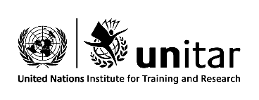l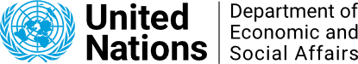bl 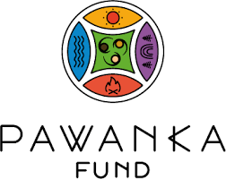
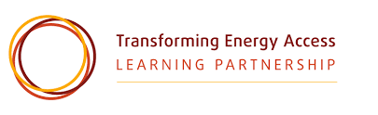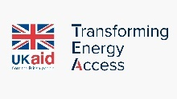 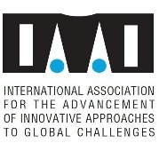 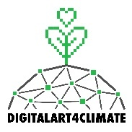 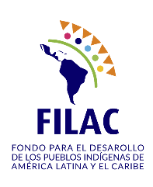ab

