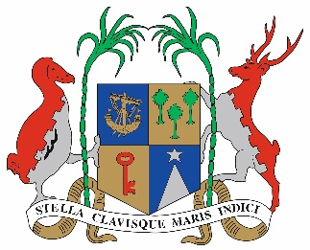

## Information Note for Participants

Small Island Developing States (SIDS) Regional Preparatory Meeting of the Atlantic, Indian Ocean and South China Sea (AIS)

**Ravenala Attitude Hotel, Balaclava, Mauritius**

**24 to 26 July 2023**

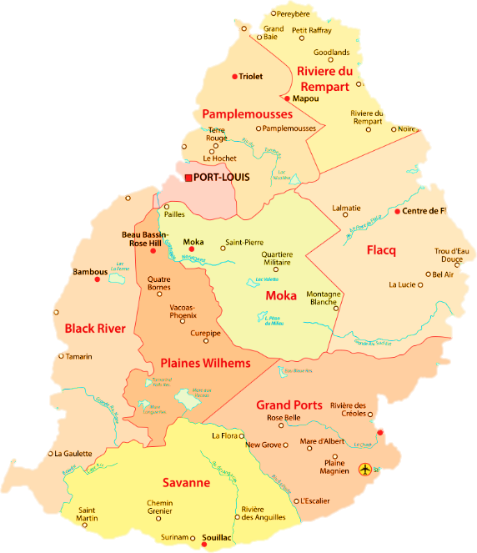Welcome to Mauritius and to the Small Island Developing States (SIDS) Regional Preparatory Meeting of the Atlantic, Indian Ocean, and South China Sea (AIS).

Mauritius is located in the South-West region of the Indian Ocean, about 2000 km from the East African coast and 900 km from Madagascar. Mauritius is of volcanic origin. It has a central plateau which is about 400 metres above the sea level. Its capital is Port Louis.

## Date

The Small Island Developing States (SIDS) Regional Preparatory Meeting of the Atlantic, Indian Ocean, and South China Sea (AIS), will be held in Mauritius from 24 to 26 July 2023, in the context of preparations for the Fourth International Conference on Small Island Developing States (SIDS4) scheduled to be held in Antigua and Barbuda in 2024.

## Conference Venue

The Conference will be hosted at the Ravenala Attitude Hotel, Balaclava. It is located on the North West coast of Mauritius. The trip from the airport to the venue is around one hour by car.

Address:

## Ravenala Attitude Hotel

Turtle Bay, Balaclava, Solitude

Mauritius, Indian Ocean Tel: (+230) 204 3000

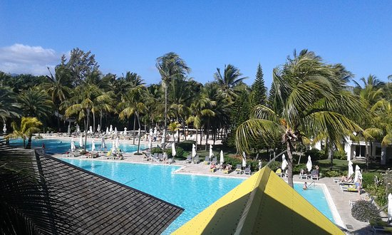

Website: [https://hotels-attitude.com/en/the-ravenala-attitude](https://hotels-attitude.com/en/the-ravenala-attitude%20)

## Issuance of Conference Badges

Badges will be delivered to participants as of Monday 24 July 2023 (0745hrs).

A dedicated desk will be set up in the main lobby of the Conference venue.

## Arrival and Departure

Arrival and departure will be through Sir Seewoosagur Ramgoolam International Airport. The airport is located 48 km southeast of the capital Port Louis.

## Transport to and from Airport

Transportation will be made available for all participants from the airport to the hotel, and back to the airport after the conference. Participants may wish to note that private taxis are also available at the airport at the approximate rate of 75-100 USD.

Transport facilities for daily commute from the hotels, listed at paragraph 7, to the conference venue will also be provided.

To avail of the transport facilities, participants are requested to forward a copy of their E-tickets and hotel booking information to the following email addresses, by 17 July 2023 at latest:

* Mr Y. Nojib Email: [ynojib@govmu.org](mailto:ynojib@govmu.org)
* Mr S. Choychoo Email: [mchoychoo@govmu.org](mailto:mchoychoo@govmu.org)

## Visa and Health Requirements

**6.1 Visa Requirements**

The following link provides information on visa entry requirements in Mauritius for each country:

<https://passport.govmu.org/passport/?page_id=605>

The following documents must be presented at the airport immigration services for participants eligible for entry visas on arrival.

* + Return Air Tickets;
  + Hotel Booking;

**Participants from countries requiring visa prior to arrival, should contact the visa section by email:** [**piomain@govmu.org**](mailto:piomain@govmu.org) **or by phone +230 210 9313/12.**

Additionally, participants, where applicable, should submit the following documents to the Passport and Immigration Office when applying for a visa to the email address provided above:

* Visa Application Form duly filled and signed by applicant;
* Two recent passport-size photos of the applicant;
* Photocopy of the data pages of applicant’s passport; and
* A copy of the Residence Permit. (Applicable for applicants not residing in their country of origin). Same to be valid for at least three months after proposed date of departure from Mauritius.

For additional information on visa application, please visit the following website:

<https://passport.govmu.org/passport>

**6.2 Health Requirements**

All passengers traveling to Mauritius are required to fill in an All-in-One Travel Digital Form which can be accessed on <https://safemauritius.govmu.org/>

## Hotel and Accommodation

Participants are responsible for the booking and payment of their accommodation directly to the hotel by latest the 2 July 2023.

Preferential rates have been negotiated with the following hotels:

* Ocean’s Creek Beach Hotel, Le Goulet Road, Balaclava.
* Maritim Resort & Spa, Turtle Bay, Balaclava.

Details about hotels and rates are at Annex I.

In the event of cancellation, please refer to the hotel’s policy.

## Social Functions

The Government of Mauritius will offer lunch and two coffee breaks during the meetings. Participants will need to make their own arrangements for other meals.

Participants will be invited to a dinner hosted by the Ministry of Foreign Affairs, Regional Integration and International Trade of Mauritius on 24 July 2023.

## Insurance

Participants are expected to make their own arrangements for accident, illness, and luggage insurance.

## Climate and Conference Attire

Mauritius enjoys a mild tropical maritime climate Conference attire should be business wear for the entire duration of the Meeting.

## Currency

The official currency of Mauritius is the Mauritian Rupee. **Mauritius**accepts **bank cards** of all common international types: Visa, MasterCard, American Express, Diners.

Bank cards are generally accepted in all established shops. Currency conversion and ATM bank withdrawals can be completed at the airport.

Persons traveling into or out of Mauritius are required to declare to custom officials at the borders if they are carrying on themselves or in their possessions MUR 500,000 cash or equivalent in foreign currency. Travellers must make this declaration by completing a Border Currency Reporting Form which will be made available at the customs counter at the airport or online at the following website: <https://eservices16.mra.mu/Currency/Index.jsp>

## Internet Services

Complimentary Wi-fi access will be available at the Meeting venue and in the hotel rooms. The network name and password will be provided upon registration. Please bring your own laptop, if desired. Printing will be available at the venue of the Conference.

## First Aid and Health Services

Phone numbers for Medical emergency is 114 and Police emergency number is 112 / 999.

First-aid Medical assistance will be provided for all participants within the Meeting premises.

Closest hospitals to the conference centre are the Sir Seewoosagur Ramgoolam National Hospital (SSRNH) situated at Pamplemousses and the Triolet Medi-Clinic situated at new market road, Triolet.

## General Information about Mauritius WEATHER AND CLIMATE

The island enjoys a maritime sub-tropical climate. The summer months extend from November to April and winter from June to September. October and May are transition periods. Coastal temperatures range between 25°C and 33°C in summer and between 18 °C and 24 °C in winter.

# LANGUAGE

The language used in the Public Service is English. Most Mauritians are fluent in French and English.

# BANKING AND CURRENCY

The local currency is the Mauritian rupee (MUR). There are a number of international and local commercial banks in Mauritius. Indicative exchange rates are:

1 US$ ≈ Rs 46

1 € ≈ Rs 50

Daily currency exchange rates is available on the website of the Bank of Mauritius at: [http://www.bom.mu](http://www.bom.mu/).

Banking hours

Mondays – Thursdays 09.00 – 15.15 hrs

Fridays 09.00 – 17.00 hrs

Week End Closed

# TIME DIFFERENCE

Mauritius is four hours ahead of Greenwich Mean Time (GMT+4).

# BUSINESS HOURS

Public Offices and major businesses are generally open from 08.45 hours to 16.00 hours from Mondays to Fridays.

# TAXIS

Reliable taxi services are provided by all main hotels.

# SMOKING

Smoking in public areas in Mauritius is strictly prohibited except in designated areas.

## Contact Persons

|  |
| --- |
| **Government of Mauritius** |
| Mr Kevin Payendee  First Secretary  Tel: +230 405 2571 ; Mobile: + 230  52562950  Email: [kpayendee@govmu.org](mailto:kpayendee@govmu.org) |
| Mr Gawrav Teelokee  Assistant Permanent Secretary  Tel: +230 405 2573 ; Mobile: + 230  59295832  Email:[gteelokee@govmu.org](mailto:gteelokee@govmu.org) |

**Annex I**

**HOTEL ACCOMMODATION BOOKING FOR AIS Meeting**

1. **Hotel Name : Maritim Resort & Spa , 5 Star – 15 rooms**

Date : 23rd - 27th July 2023 ( 04 nights)  
  
Room Category : Run of the House  
  
Rates : Bed & Breakfast : USD 195 on Single Occupancy per room per night. (01pax)  
                                  : USD 245 on Double Occupancy per room per night (02 pax)  
  
              Half Board     : USD 230 on Single Occupancy per room per night (01pax)  
                                  : USD 285 on Double Occupancy per room per night(02pax)

The Booking Code for the Delegates is**MAU/UN/2023**and the email address to be used for booking is [**reservation.mau@maritim.com**](mailto:reservation.mau@maritim.com)

Above Rates in US Dollars inclusive of Government tax and commission not applicable.  
  
Payment Terms : Full Payment upon confirmation.  (Paid directly by guests)

For other requirements and queries, the hotel can be contacted directly on **reservation.mau@maritim.com**

1. **Ocean’s Creek Beach Hotel, Le Goulet Road, Balaclava, 4 star- 75 rooms**

Rates:

Comfort Room : USD 160 per room per night on Bed & Breakfast Basis on Single Occupancy

Superior & Family Rooms: USD 180 per room per night on Bed & Breakfast Basis on Single Occupancy

The rates are available between 20 – 30 July 2023, for any pre and post stay requirements due to flights

Link is as follows:

<https://be-p1.synxis.com/?adult=2&arrive=2023-07-20&chain=14463&child=0&clearcache=all&config=ocmconfig&currency=USD&depart=2023-07-21&hotel=40989&level=hotel&locale=en-US&promo=UNCONFERENCE&rooms=1&theme=ocmthemered>

For other requirements and queries, the hotel can be contacted directly on [reservations@oceanscreekmauritius.com](mailto:reservations@oceanscreekmauritius.com) and [stephanie@oceanscreekmauritius.com](mailto:stephanie@oceanscreekmauritius.com)