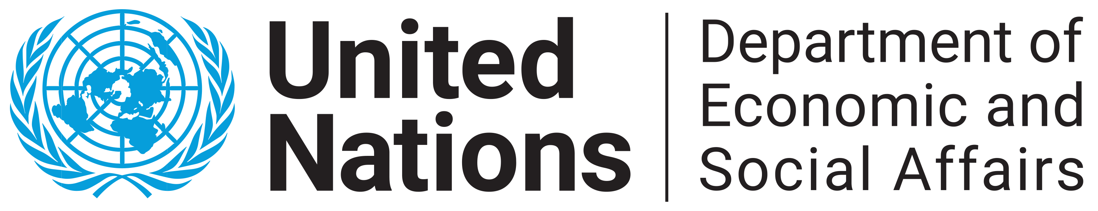

High Level Policy Workshop

Mainstreaming Micro-, Small and Medium-sized Enterprises (MSMEs) in the implementation of African Free Trade Continental Area (AfCFTA) in The Gambia
15 December
(Final Programme)

Sessions/Time | Activities | Moderator
Opening Session  (9.00-10.00am) | Statement - Mr. Amson Sibanda, Chief, National Strategies and Capacities Building Branch, Division for Sustainable Development Goals, Department of Economic and Social Affairs (NSCBB, DSDG/DESA)  Statement - Ms. Aissata De, Resident Representative - United Nations Development Programme (UNDP)  Statement - Hon. Seedy Keita, Minister of Trade, Industry, Regional Integration and Employment  Opening Statement – Dr Isatou Touray, the Vice President of the Republic of The Gambia | Mr. Ebrima Sisawo, Permanent Secretary, Ministry of Trade, Industry, Regional Integration and Employment, MOTIE
Coffee Break (10.00-10.30am)
Session one  (10.30-13.00pm) | National Strategy for AfCFTA Implementation: What are the accompanying measures and benefits for the Gambian MSMEs (by Abdoulie Jammeh, Deputy Permanent Secretary, MoTIE)  AfCFTA and MSMEs: How to Harness the benefits of AfCFTA using ICT (by Hassan Jallow, Founder and Chief Software Architect, Assutech)  Q&A session  The Draft Monitoring Framework for the Informal Sector (by Ms. Sheyi Oladipo, State University of New York)  Q&A session | Mr. Amson Sibanda, Chief, NSCBB, DSDG/DESA  Mr. Fabba Jammeh, Director of Industry and Investment, MOTIE
Lunch Break (13.00-14.30pm)
Session Two  (14.30-16.00pm) | The impact of the AfCFTA implementation on MSMEs in The Gambia (by Professor Mustapha Fanneh, University of Gambia)  Enhancing MSME resilience in the AfCFTA implementation during the recovery from the COVID-19 pandemic (by Alhajie Jallow, Principal Economist, MoFEA)  Q&A session | Mr. Ebrima Sisawo, Permanent Secretary MoTIE
Presentation by rapporteur on key messages and follow up steps
(16.00-16.15pm)
Closing session  (16.15-16.30pm) | Mr. Ebrima Sisawo, Permanent Secretary MoTIE

