**Workshop on Accelerating the Implementation of the 2030 Agenda and AU Agenda 2063 in Africa: Building Resilient Institutions for the SDGs in the time of COVID-19**

**Co-organized by APRM and UN DESA**

**Cape Town, Radisson Blu V&A Waterfront**

**28-30 October 2021**

**Biography of moderators and speakers**

**Opening**

**Eddy Maloka**, Chair Africa Governance Architecture and Chief Executive Officer, African Peer Review Mechanism

Professor Maloka, from South Africa, is the Chief Executive Officer of the African Peer Review Mechanism (APRM) and adjunct professor at the University of Witwatersrand’s School of Governance, Public and Development Management. 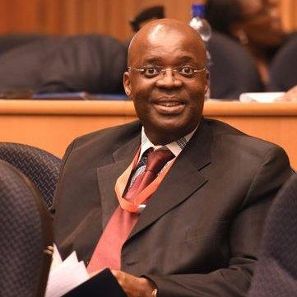He previously served as Special Advisor to the Minister of International Relations and Cooperation of South Africa and as Advisor to NEPAD. He has been a member of the African Legacy Delegate and the 2010 FIFA World Cup Organizing Committee, the Chief Executive Officer at the Africa Institute of South Africa (ASIA), and a lecturer at the University of Cape Town. Prof. Maloka holds an MA in development studies from the University of Geneva, a PhD in history from the University of Cape Town and was a postdoctoral fellow at Princeton University.

**Maria-Francesca Spatolisano,** Assistant Secretary-General for Policy Coordination and Inter-Agency Affairs, United Nations Department of Economic and Social Affairs

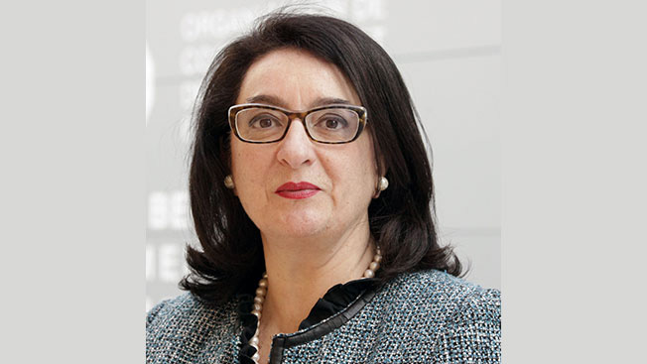Ms. Spatolisano has 33 years of experience in public service including extensive senior leadership in multilateral affairs. She has served as the European Union Ambassador to the OECD and UNESCO, Monaco and Andorra. She was a member of the EU Delegation to the United Nations, serving as the Head of its Economic and Trade Section. She covered all issues related to trade, development and environmental policies in the Second Committee and ECOSOC and was also the EC representative to the Fifth Committee. Since 2017, she has been responsible for International Organizations and Development Dialogue with other Donors in the Commission’s Directorate General for Development Cooperation. In this capacity, she has assured the EU presence and developed EU positions on development policy in several international fora including the United Nations, the World Bank and International Monetary Fund, OECD, G-7 and the G-20. Ms. Spatolisano holds a Doctorate in Law from Florence University.

**Geraldine Fraser-Moleketi,** Chancellor of Nelson Mandela University and Chair of the United Nations Committee of Experts on Public Administration

Ms. Fraser-Moleketi is the Chancellor of Nelson Mandela University and the Chairperson of the UN Committee of Experts on Public Administration (CEPA).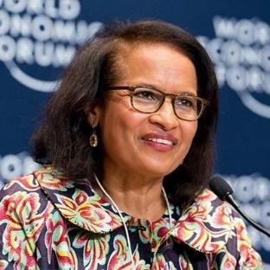 Previously, she served as African Development Bank’s Special Envoy on Gender and UNDP’s Director of the Democratic Governance Group. She was the Minister of Public Service and Administration of South Africa for two consecutive terms. She serves on various boards in academia, government and development organizations on issues related to sustainable development. She was named New African Woman of the Year in 2016. She is a fellow of the Institute of Politics, Kennedy School of Government, Harvard University. She holds an MA in Administration and was conferred a PhD (Honoris Causa) by the Nelson Mandela Metropolitan University.

**Ayanda Dlodlo**, Minister of Public Service and Administration, South Africa

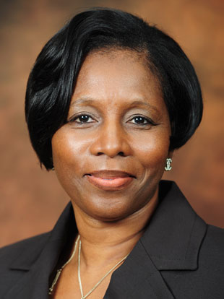

Ms Ayanda Dlodlo was appointed as Minister for the Public Service and Administration on 5 August 2021. She is a member of the African National Congress (ANC) and a Member of Parliament. Ms Dlodlo was the Minister for State Security from the commencement of the 6th government administration in June 2019. Before then, she served as the Minister of Public Service and Administration (2018 – 2019), Minister of Home Affairs (2017 – 2018) and as Minister of Communication in mid-2017. She also served as the Deputy Minister for Public Service and Administration, a position she held from 2010 until March 2017, after serving as the Parliamentary Counsellor to the President between 2009 and 2010. Ms Dlodlo holds a Masters in Business Administration (MBA) amongst a number of postgraduate qualifications in Management Development, Business Management and Executive Development Programmes.

**Session 1: Accelerating Implementation of the 2030 Agenda and 2063 Agenda in Africa**

**Nardos Bekele-Thomas,** United Nations Resident Coordinator in South Africa

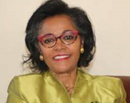Ms. Bekele-Thomas, from Ethiopia, is currently the Resident Coordinator of the United Nations to South Africa. Previously, she served as the Senior Director in the Office of the Secretary-General, Office of the Chef de Cabinet and the Deputy Secretary-General. She was also the UN Resident Coordinator and UNDP Resident Representative in Kenya and Benin. She is a member of the Group of African Eminent Women; a recipient of the prestigious AU/DAF (African Union-Diaspora African Forum) Award of “2015 Woman of Excellence”. Ms. Bekele-Thomas holds an MA in Economics from New York University.

**Obeth M. Kandjoze,** Director General, National Planning Commission, Namibia

Hon. Kandjoze was appointed Director General of the National Planning Commission and Minister of Economic Planning on February 2018. Hon. Kandjoze is a member of the Cabinet of Namibia and is the Chairperson of the Cabinet Committee on Trade and Economic Development. Hon. Kandjoze serves as a Member of the following Cabinet Committees: Cabinet Committee on Land and Social Issues; Cabinet Committee on Legislation; Cabinet Committee on Treasury; Cabinet Committee on Water Supply and Security; and the Cabinet Committee on Public Enterprises. Hon. Kandjoze is the former Minister of Mines and Energy. Hon Kandjoze has for the last 6 years been actively involved politics given his appointment as Minister of Mines and Energy on 21 March 2015. He holds a Master of Science degree in Geology with the University of Helsinki-Finland, a Bachelor of Science degree in Geology with Cape Town University (UCT-RSA) and a Management Development Program Certificate with the University of Stellenbosch. Prior to the appointment of his first Ministerial role as Minister of Mines and Energy, Hon. Kandjoze began his career in private sector, Government and parastatal organizations within the Namibian oil and gas sector, bringing his total industry experience to over 18 years. Before assuming the ministerial positions, Hon Kandjoze held the position of MD of National Petroleum Corporation of Namibia (NAMCOR). Hon. Kandjoze is also a researcher. His publication reference is: O.M. Kandjoze (1994), “Regional Mapping in the north-western Namibia and Satellite Imagery" Unpublished MSc Thesis, University of Helsinki, Finland.

**Caroline Makasa,** Acting Director General, SDGs Centre for Africa



Ms. Makasa, is the Acting Director General at The Sustainable Development Goals Center for Africa (SDGC/A). Prior to Joining the SDGC/A, Caroline worked in the area of international trade promotion for many years. She started her career at the Export Board of Zambia as a market research officer in April 1999. This included conducting detailed market surveys, organizing trade missions and buyer to seller meetings. Notably she led business delegations to numerous global trade fairs and exhibitions. She later served as a Senior Market Development Specialist at the Zambia Development Agency where she played a pivotal role in enhancing regional trade and Sustainable development. Furthermore, she also previously worked on projects such as the European Union Mining Sector Diversification Programme, the United Nations Industrial Development Organization Trade Capacity Building Framework Programme and the World Bank Governance Partnership Facility Programme in Zambia and Uganda. Caroline holds a Master of Science degree in Sustainable Development from the University of London School of Oriental and African Studies, a Bachelor’s degree in Economics from the University of Namibia, and a Diploma in Environmental Management from Maastricht School of Management in the Netherlands.

|  |
| --- |
| **Session 2: Institutions and the Decade of Action and Delivery in Africa: Responding to the COVID-19 pandemic** |

**Ayodele Odusola,** Resident Representative, United Nations Development Programme

Mr. Odusola, from Nigeria, is the Resident Representative of UNDP to South Africa.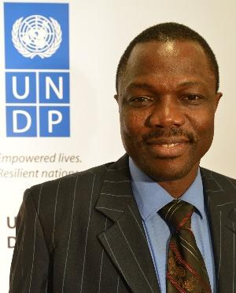 Previously, he served as the Chief Economist and Head of the Strategy and Analysis for UNDP Regional Bureau for Africa in New York. He chairs UNDP’s Corporate Technical team on the Least Developed Countries and Landlocked Developing Countries. He also supports the organization of the International Conferences of the Emergence of Africa and Tokyo International Conference on Africa’s Development (TICADI). In 2001, he was the African Visiting Scholar to the International Monetary Fund. Dr. Odusola holds a PhD in Economics from the University of Ibadan, Nigeria.

**Eric Simiyu Wafukho**, Chief Administrative Secretary, State Department of Planning, Kenya

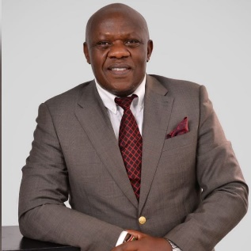Mr. Wafukho is a leadership and governance consultant with vast experience in leadership space that spans more than 20years of leading at the top in both development agencies and educational institutions. Has served both in Africa and outside Africa in countries like Jamaica, rising from International Representative to Country Director for organisations like Canpus Crusade for Christ, World Vision and World Relief. Has served on Boards of corporate and educational institutions including serving as Chairman of International Leadership University Governing Council. A sought-after international conference speaker and a leadership coach with over 100 leadership development programs and an accomplished author with more than 16 books on leadership and community transformation to his credit. He holds a first degree in Mathematics and post-graduate studies in leadership, finance, community building and conflict management. Currently he serves as Chief Administrative Secretary in the Ministry of National Treasury and Planning.

**Sibusiso Nkomo**, Head of Communications, Afrobarometer, Cape Town office

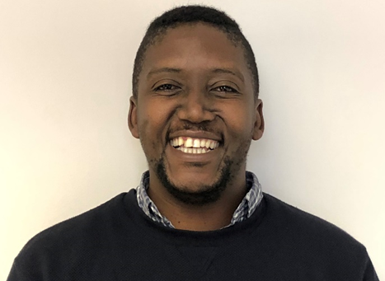

Mr. Nkomo is head of communications and partnerships at Afrobarometer. He is also a senior project leader in the research and policy programme at the Institute for Justice and Reconciliation in Cape Town, South Africa. He previously worked as a journalist at The Sunday Independent and then a researcher on African politics at Good Governance Africa. He holds degrees from Stellenbosch University (BA) and the University of the Witwatersrand, Johannesburg (MA). He is registered as a Chartered Public Relations Practitioner (CPRP) with the Public Relations Institute of Southern Africa (PRISA). Mr. Nkomo is also a visiting academic and member of the management committee of the Institute for Democracy, Citizenship and Public Policy in Africa, University of Cape Town.

**Salah Hammad**, Head of African Governance Architecture (AGA)

**Augustin K. Fosu**, Member, Professor, Institute of Statistical, Social and Economic Research (ISSER), University of Ghana, Member, UN Committee of Experts on Public Administration

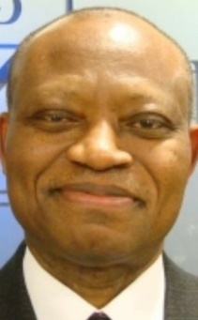

Prof Fosu is Professor of Economics, Institute of Statistical, Social and Economics Research, University of Ghana; Distinguished Visiting Professor, College of Business and Economics, University of Johannesburg; Extraordinary Professor, Economic and Management Sciences, University of Pretoria; and Research Associate, Centre for the Study of African Economies, University of Oxford. Prof. Fosu has also served as Deputy Director, UN University-WIDER, Helsinki; Senior Policy Advisor/Chief Economist, UN Economic Commission for Africa, Addis Ababa; and Director of Research, African Economic Research Consortium, Nairobi. He holds a PhD in economics from Northwestern University, USA. Dr Fosu has published extensively. He was the August 2017 recipient of the Elsevier Atlas Award. He has served on the editorial boards of numerous international journals, including: Journal of African Economies, Journal of Development Studies, Oxford Development Studies, World Bank Economic Review, and World Development. Currently, he is the Editor-in-Chief of the Journal of African Trade (Atlantis/Elsevier) and a managing editor of the Journal of African Economies (Oxford). Prof. Fosu has also served in various advisory and consultancy capacities for international organizations and has been engaged in numerous fora globally. Currently, he is a member of the UN Committee of Experts on Public Administration (CEPA). Locally, in Ghana, he has served, inter alia, on the President’s Economic Advisory Council, President’s Fiscal Responsibility Advisory Council, and on the Eminent Panel for Ghana’s Priorities.

**Session 3: Accelerating recovery from the impacts of COVID-19**

**Amson Sibanda**, Chief, National Strategies and Capacity Building Branch, Division for Sustainable Development Goals, UN DESA

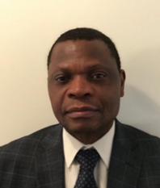Mr. Sibanda is Chief, National Strategies and Capacity Building Branch, Division for Sustainable Development Goals, United Nations Department of Economic and Social Affairs (UN DESA). He leads and manages the activities undertaken by the Branch that support DESA’s operational work aimed at building capacities of developing countries to translate the 2030 Agenda for Sustainable Development and other internationally agreed policy frameworks and programmes at global, regional and country-levels. He also oversees the work of the Department of Economic and Social Affairs’ two project offices, the United Nations Office for Sustainable Development (UNOSD) in the Republic of Korea and the United Nations Center for Regional Development (UNCRD) in Japan. These project offices carry out several capacity development activities to support developing countries in planning and implementing sustainable development strategies and promoting sustainable regional development and awareness of environmental issues. Mr. Sibanda holds a Doctorate and an M.A. in Demography from the University of Pennsylvania, an MSc in Population Studies and B.A. in Geography (Honours) from the University of Zimbabwe.

**Bakary Koné**, Head, Regional Office for West & Central Africa & Director, Resource Mobilization, Strategic Planning & Partnerships, Africa Capacity Building Foundation

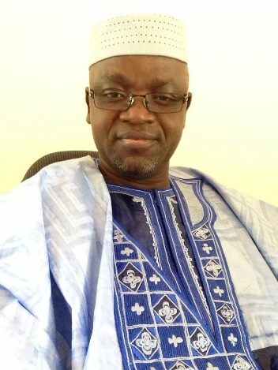

Mr. Koné joined ACBF in July 2005, bringing to the Foundation two decades of professional experience in the private sector and the United Nations. In the private sector, Mr. Kone worked for Arthur Andersen as an Auditor, conducting auditing assignments in France and West and Central Africa, and for DHL as Regional Finance Manager Francophone West Africa. At the United Nations, he worked for the UN Refugee Agency, the United Nations High Commissioner for the Refugees (UNHCR) as a Program Officer in Côte d’Ivoire and for UNICEF as Chief of Operations in Guinea and Iraq. Mr. Kone’s current responsibilities at ACBF include oversight of the Foundation’s Monitoring and Evaluation Team. Mr. Kone is a national of Côte d’Ivoire and holds a Master’s Degree in Business Administration from the Ecole Supérieure de Commerce d’Abidjan, majors in Accounting and Finance. Mr. Kone holds a Post Graduate Certification International Development Project Management from the University of Quebec at Montreal.

**Zwelinzima Ndevu**, Director, School of Public Leadership, University of Stellenbosch

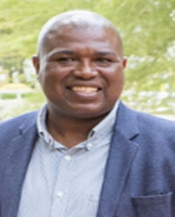Professor Ndevu is the Director at the School of Public Leadership (SPL) at Stellenbosch University and an Academic Head: Honours in Public Development and Management in SPL responsible for lecturing undergraduate and postgraduate students and a professional associate at the Anti-Corruption Centre for Education and Research of Stellenbosch University (ACCERUS), South Africa. An expert in the field of Public leadership, Human Resource Management with specialisation on Performance Management, Ethics, Public Participation and Local Government. He has published peer-reviewed chapters in books, accredited journal articles and peer-reviewed national and international conference proceedings. He is a supporter of inter-disciplinary research which leads to numerous capacity-building projects in South Africa; training short courses; professional consultation and study supervision of Master’s and Doctoral students projects; appointed as an external examiner for the Nelson Mandela Metropolitan University; Cape Peninsula University of Technology; University of Fort-Hare; University of the Western Cape; Tshwane University of Technology and Management College of South Africa.

**Sherifa Fouad Sherif**, Executive Director of the National Institute for Governance and Sustainable Development, member, UN Committee of Experts on Public Administration

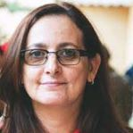

Prof. Sherif is a Professor of Public Administration at the Faculty of Economics and Political Science of Cairo University. She is the Executive Director of the National Institute for Governance and Sustainable Development, the training arm of the Ministry of Planning and Economic Development. Dr. Sherif was the Executive Director of the National Management Institute from 2018 to 2020. She was the Vice-Dean for Environment and Community Services and Chairperson for the Public Administration Department at Future University, in Egypt, and an Adjunct Professor at several universities in that country. From 2015 to 2018, she was the Head of the Public Administration Research and Consultation Center at the Faculty of Economics and Political Science of Cairo University. Dr. Sherif has been teaching for more than 20 years in the areas of public administration, management, corporate social responsibility, sustainable development, social entrepreneurship, environmental management, gender and governance. She has published many research papers and articles in both national and international journals in her areas of specialization and was granted the Best Paper Award for several of her publications. Dr. Sherif has worked with multiple international organizations as a researcher and lead consultant on projects related to gender equality, the empowerment of women, good governance, administrative reform, sustainable development and environmental management. She was appointed in 2017 as a member of the Egyptian National African Peer Review Mechanism Committee, as well as the Egyptian National Coordinator for the Public Governance Committee of OECD. Dr. Sherif has a Bachelor of Arts degree in Business Administration and a Master of Public Administration degree from the American University, in Cairo, as well as a PhD from the University of Sussex, in the United Kingdom.

**Session 4: Principles of Effective Governance for Sustainable Development: Findings from the APRM Baseline Study**

**Sara Tawfik Hamouda,** SDGs and Agenda 2063 Unit, Officer-in-Charge, APRM Secretariat

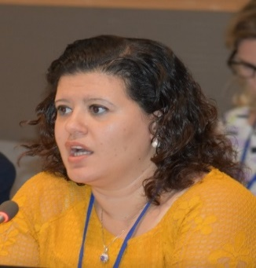 Ms. Sara Tawfik Hamouda is Officer-in-Charge of the SDGs and Agenda 2063 Unit at the African Peer Review Mechanism. She has a substantial experience in development and international cooperation fora through her working experience at the Cabinet of the Minister of International Cooperation in Egypt for seven years. Previously, Ms. Hamouda has managed Development Cooperation portfolios with several donors such as the international and regional funding institutions, China and South-East Asia and she also got a professional trainee-ship at European Investment Bank in Luxembourg. Ms. Hamouda holds a Bachelor of Political Sciences from the faculty of Economic and Political Sciences at Cairo University and a Master’s degree in international Development at Hankuk University in South Korea. She also hold a diploma in Peace and security issues from University of Peace and Centre for Disarmament (Vienna).

**Pali Lehohla**, former Statistician-General, South Africa

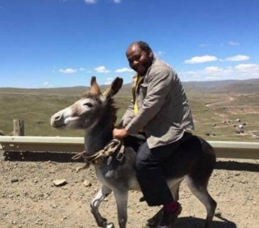

Dr. Lehohla is the former Statistician-General of South Africa, a position he held from 2000 up to 2017. He has served as co-chair of PARIS21 and the Chair of the United Nations Statistics Commission. He was the founding chair of the Statistics Commission of Africa (StatCom Africa) and chairs the African Symposium for Statistical Development (ASSD). He was the Vice President of the International Statistics Institute (ISI), and sponsors the Young African Statistician (YAS) movement. He served as one of on the twenty-five-member panel on Data Revolution appointed by the UN Secretary General and was a member of the Independent Accountability Panel for the health of women, children and adolescents. He is the deputy chair of the board of the International Network of Demography of Populations and their Health (INDEPTH). Dr Lehohla has been a forceful advocate for improving the Civil Registration and Vital Statistics systems in Africa. He consulted extensively in the in conflict, out of conflict and fragile states on matters statistics. And this saw him cover Iraq, Afghanistan, Sudan and Cambodia to make some mention. He was recognized by his alma mater, the University of Ghana for his contribution to the development of statistics in 2015 and was also awarded an Honorary Doctorate by the University of Stellenbosch in the same year and in 2018 the University of Kwa – Zulu Natal awarded him an Honorary Doctorate. In October 2018 the University of Johannesburg appointed Dr Lehohla as a Professor of Practice. He consults widely on matters statistics and since 2017 he became a Research Associate at Oxford University and a consultant to Oxford Poverty and Human Development Initiative (OPHI). He is the Founder of the Pan African Institute for Evidence (PIE). He is a member of the Idlulamithi Steering Committee. For twenty years to date he has been weekly columnist in the Business Report.

**Zenene Sinombe**, Representative of Botswana to the African Union

**Ashraf Gamal Rashed,** African Peer Review Mechanism National Governance Council, Egypt

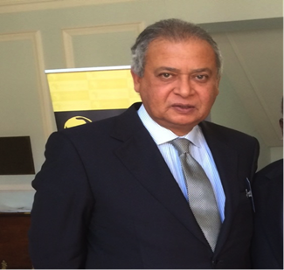

Ambassador Rashed is currently Chairperson of the African Peer Review Mechanism (APRM) National Commission of Egypt (since 2017), Foreign Relations Advisor to the President of the Central Agency for Organizing and Administration (CAOA), Member of the Board of Trustees of the National Institute for Governance and Sustainable Development (Ministry of Planning & Economic Development), Member of the Board of Trustees of the Egyptian E-Learning University, and Member of the Board of Directors of the Cairo International Center for Conflict Resolution, Peacekeeping and Peace Building, and Member of the Egyptian Council for Foreign Affairs, the Italian/Egyptian Business Council. Ambassador Rashed is also Chairperson of the Continental Task Force for Deeping the Governance Review Processes in Africa, Chairperson and member of the COMESA Committee of Elders (since 2015) which addresses issues related to Peace, Security and Governance in the COMESA region, Member of the Committee which prepared the Africa Governance Report, adopted by the African Union Summit, 2019. He has held various positions such as Vice Chairperson & member of the African Peer Review Panel of Eminent Persons (2012 – 2017). During his tenure, Ambassador Rashed gained experience in the promotion of Good Governance in the Continent, including Political, Economic and Social Governance, with direct implications on Conflict Prevention, Peace Building and Sustainable Development; Ambassador to Italy and Permanent Representative to the UN Agencies in Rome (2006-2011), and Ambassador to Ireland (1999-2003). Furthermore, he also worked as international consultant for the World Food Program as Facilitator and Chairperson for the consultations on humanitarian assistance and risks in Somalia, participants included UN Agencies, Special Representative of UN Secretary General, Regional Organizations, NGOs, and Donor Community (June-September 2011). Ambassador Rashed was also assistant Foreign Minister for European Affairs, and Arab Coordinator for the Euro – Mediterranean Cooperation (2004-2006) and Assistant Foreign Minister for African Affairs (February – September 2004).

**Saitoti Torome*,*** Principal Secretary, State Department for Planning, Kenya

**Session 5: Mainstreaming the 2030 Agenda and Agenda 2063 into national planning instruments and strategies**

**Kefiloe Masiteng,** Deputy Secretary of National Planning, Department of National Planning, Monitoring and Evaluation, South Africa

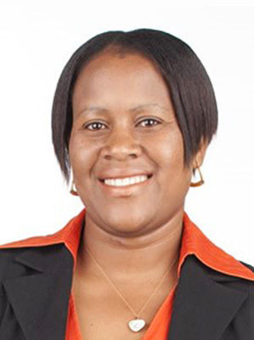

Ms. Masiteng is Deputy Secretary for planning in the National Planning Commission of South Africa. She has extensive experience in the area of governance, monitoring and evaluation gained over the past 15 years in government. Her portfolio at Stats SA includes Census 2011, poverty and inequality research, labour statistics, social statistics, household surveys, health statistics, government-wide monitoring and evaluation systems, and technical advice on monitoring and evaluation. She is also the Founder of Camp LaThuso, which provides children with various camp activities. Dr. Masiteng holds a Master’s in Public Health from the University of Pretoria, a PhD in Public and Development Management at the University of the Witwatersrand.

**Malefu Delinah Khanyapa**, Director for Monitoring and Evaluation, Ministry of Development Planning, Maseru, Lesotho

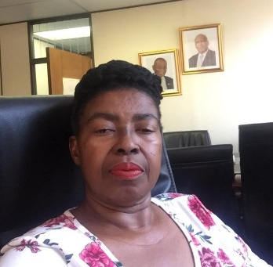Ms. Khanyapa is the Director, Department of Monitoring and Evaluation (M&E) in the Ministry of Development Planning of the Government of Lesotho. She*has* worked both in the public sector and with the United Nations in various capacities. She has worked in various Ministries as an Economic Planner at different levels. She has also worked at UNICEF as a Monitoring and Evaluation Officer. Furthermore, Ms. Khanyapa worked for UNDP as the National Monitoring and Evaluation Technical Coordinator for UNDP-funded project, which was meant to establish the Lesotho National Monitoring and Evaluation System (NMES) and strengthen capacities of the national machinery in M&E. She is an experienced professional who holds a Certificate in Statistics, a BA Degree in Economics and Statistics both obtained from the National University of Lesotho, and a Master of Science Degree in Macro-Economic Policy and Planning in Developing Countries obtained from the University of Bradford, UK). She has also gained skills in various subject areas in project management such as project cycle management, results-based management, procurement and disbursement and results-based M&E. She has participated in several trainings on Monitoring and Evaluation, including managing M & E in crisis and unstable situations. She speaks both Sesotho (mother tongue) and English fluently.

**Admos Chimhowu**, Associate Professor, Global Development Institute, University of Manchester

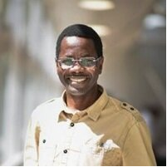Mr. Chimhowu works as an Associate Professor at the University of Manchester’s Global Development Institute where he also currently serves as Deputy Associate Dean for Post Graduate Research in the Faculty of Humanities. As a researcher and international development and policy expert, Mr. Chimhowu specialist skills are in the planning, administration, and management of development in emerging economies. Much of his experience in development policy and practice interventions is on sub-Saharan Africa and South Asia. His research is devoted to understanding the relationship between ‘place’ and ‘economy’ in rural Africa. He has sought to generate policy relevant knowledge on how changing agrarian structures transform and influence the way rural communities relate to natural resources (particularly land) and, how this relationship in turn shapes the way they make a living. More recently he has begun to research how countries have used national development planning to respond to the Covid-19 Pandemic and how they have sought to integrate sustainable development goals and AU's Agenda 2063 to structure responses.

**Session 6: Lessons learned from Implementation at Local Levels and Voluntary Local Reviews (VLRs)**

**Natasha Primo,** Head of Organizational Research, City of Cape Town SDG and VLR lead

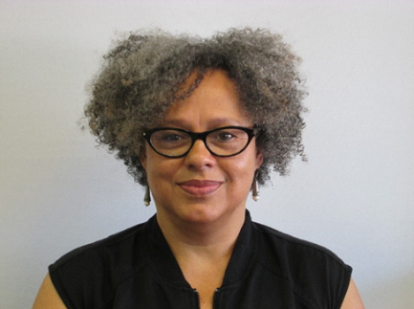

Ms. Primo joined the City of Cape Town in January 2011. She is the Head: Organisational Research in the Policy and Strategy Department, where among others, she is responsible for overseeing and/or implementing components of the City’s research management framework, which includes serving as a research consultancy for line departments, coordinating a transversal research community of practice, and leading a transversal process for SDG localisation in the City. Before joining the CCT, Ms. Primo spent 10 years in the ICT4D sector as coordinator on ICT policy advocacy research in an international NGO, and as executive director of a Johannesburg-based NGO that trained girls and women’s organisations in using new media technologies for gender/feminist advocacy. Prior to that, she worked in the higher education sector as the first coordinator of the University of the Western Cape post-graduate women and gender studies programme, and in the Human Sciences Research Council and National Research Foundation implementing research capacity development interventions for early career women researchers.

**Simon Masanga**, Permanent Secretary, Ministry of Public Service, Labour and Social Welfare, Zimbabwe

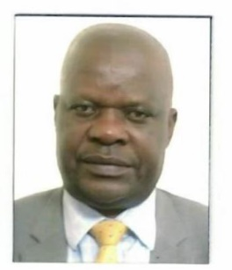 Mr. Simon Masanga is the Permanent Secretary for the Ministry of Public Service, Labour and Social Welfare in Zimbabwe. He is a career civil servant who has worked in various Government Ministries. He has previously served as the Head Human Resources Management and Development at the Public Service Commission as well as the Principal Director in the Ministry of Public Service, Labour and Social Welfare where he was the Country Focal Person for Sustainable Development Goals. Simon started his career in the public service in 1991 as a Human Resources Practitioner. He was later promoted to Human Resources Director in the Ministry of Lands and Agriculture in 2005. In 2014, he moved to the Ministry of Youth where he was elevated to Principal Director Youth Development in March 2016. He is currently the Chairperson of the Zimbabwe Occupational Health and Safety Council.

Simon has served as a board member in various organisations and other councils, which include Grain Marketing Board, Rainbow Tourism Group, the East and Southern Africa Management Institute and Pan-African Productivity Association among others. He holds several professional qualifications including a Masters in Public Sector Management. He has vast experience in corporate governance, strategic planning, leadership and is an accomplished motivational speaker.

**Asio Priscilla Margery**, District Planner, Ngora District Local Government, Uganda

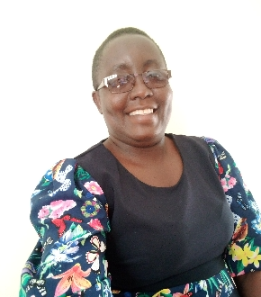Ms. Margery is a District Planner in Ngora District Local government, with experience in planning for a period of about 10 years. Ms. Margery is also a coordinator of SDGs in the Ngora district local government. She studied Bachelor of Science in Population Studies, Demographics, Project planning and Management. Her key roles and responsibilities include, planning and budgeting, strategic planning development planning, operational planning, statistical production, and monitoring and evaluation.

**Jan Magoro**, Acting Chief Director, Policy Research & Advisory Services Branch, Office of the Premier, Gauteng Province

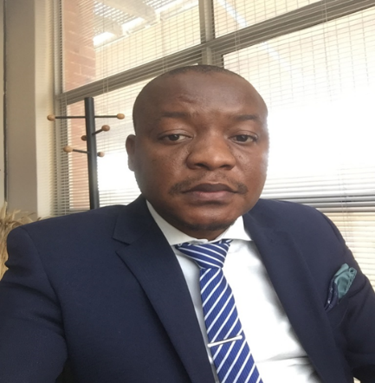Mr. Magoro is currently the Acting Chief Director responsible for Research and Policy Development in Gauteng Office of the Premier. His areas of work include amongst others, developing the research agenda, data management centre, strategic research partnerships, and reviews and quality assures public policies, legislation, and regulations through the Socio-Economic Impact Assessment System (SEIAS)-an ex-ante policy analysis tool. He holds Masters’ Degree in Public Policy from University of Pretoria. Currently pursuing Doctorate in Business Administration with a focus on beneficiation of mining waste to create the circular economy whilst also contributing to Sustainable Development Goals.

**Ken Oluoch,** Sustainable Development Goals Technical Lead, Kenya Council of Governors

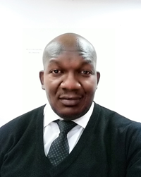

Mr. Oluoch holds an MA Degree in Social Development and Management from Maseno University and a Bachelor’s Degree in Environmental Planning and Management from Kenyatta University. He also holds a postgraduate Diploma in Environmental Systems Management from Galilee International Management Institute. He is a Fellow from Danida Fellowship Centre in Policy Dialogue for accelerating SDGs implementation. He has vast experience in the field of Sustainable Development and Community Development having held different positions in many organizations. Mr. Oluoch is currently the Technical Lead for SDGs at the Council of Governors supporting mainstreaming of SDGs in the County Governments in Kenya.

**Rogers Dhliwayo,** Senior Economist, UNDP South Africa

Mr. Dhliwayo is an Economics Adviser/Senior Economist at UNDP South Africa Country Office. Over three decades, he has worked as an economist in academia and policy advisory in Zimbabwe, Mozambique, South Africa, Botswana, Tanzania and Kenya working for the Reserve Bank of Zimbabwe, University of Zimbabwe, Catholic University of Mozambique, Embassy of Switzerland/Swiss Development Corporation in Mozambique, Productivity SA/South Africa, World Bank and UNDP. He has written several research and policy papers on macroeconomic policies for stability, growth and poverty reduction, inequality, public debt management, economic impact of violent extremism and terrorism, middle income trap, financing the Sustainable Development Goals (SDGs), managing natural resource for sustainable human development, among others

**Session 7: Mobilizing Partnerships and Stakeholders for 2030 Agenda and 2063 Agenda implementation and COVID-19 recovery**

**Bartholomew Armah**, Director a.i., Macroeconomics and Governance Division, UNECA

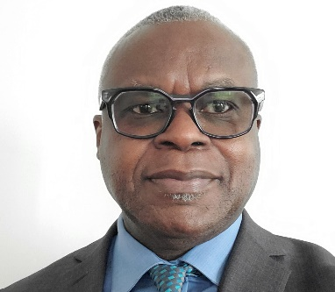Professor Armah is currently the Director a.i. of the Macroeconomics and Governance Division of ECA. Prior to joining the UN Economic Commission for Africa, he was a tenured Professor at the University of Wisconsin-Milwaukee. He recently served as the Policy and Planning Coordinator of the UN Secretary General’s Transition Team for the reform of the development system. He served in several capacities in the UN including as a Policy Adviser in UNDP’s Crisis Prevention and Recovery Bureau and as Chief of Development Planning in UNECA’s Macroeconomics and Governance Division where he spearheaded the design of ECA’s *Integrated Planning and Reporting Tool* which maps the SDGs to Africa’s *Agenda 2063* and automates the alignment of planning frameworks to both commitments. His latest publication, “*Prioritizing interventions for sustainable structural transformation in Africa: a structural equation modelling approach”* provides a framework for policymakers to optimally sequence economic, social and environmental policy interventions for the achievement of sustainable structural transformation.

**Mohamed Khalil**, Secretary General, Egyptian Agency of Partnership for Development

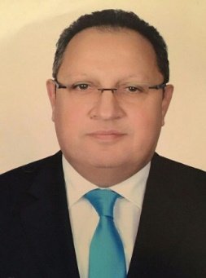Ambassador Khalil has been Secretary General of the Egyptian Agency for Partnership for Development, Ministry of Foreign Affairs since October 2020. Prior to this, he was Ambassador Extraordinary & Plenipotentiary of the Arab Republic of Egypt to the Republic of Albania from 2016 to 2020. Previously, he has served in various capacities such as Deputy Secretary General Deputy Secretary General of the Egyptian Agency of Partnership for Development (2014-2016); Consul General of Egypt in Port Sudan (2011-2014; Office of the Assistant Minister of Foreign Affairs for Parliamentary Affairs (2010-2011); Deputy Consul General of Egypt in New York, U.S.A. (2006-2010); Office of the Deputy Assistant Foreign Minister for Gulf Cooperation Council and Yemen Affairs (2005-2006); Office of the Assistant Foreign Minister and Director of Diplomatic, Consular and Inspection Affairs (2005) and Embassy of Egypt in Pretoria, South Africa (2001-2005); among others. Ambassador Khalil has represented Egypt in various conferences and workshops held in Albania, country that chaired the presidency of the OSCE in 2020. He has also participated in various regional and international meeting that included the African Union, Non-Aligned movement and NEPAD, among others. He holds a Bachelor of Arts in Political Sciences from the Cairo University.

**David Moinina Sengeh,** Minister of Basic and Senior Secondary Education, Sierra Leone, Member UN Committee of Experts on Public Administration (CEPA)

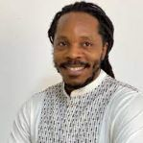Dr. Sengeh was appointed Cabinet Minister of Basic and Senior Secondary Education in November 2019 and has served as Chief Innovation Officer in the Directorate of Science, Technology and Innovation of the Government of Sierra Leone since 2018. From 2016 to 2018, before joining the Government, Dr. Sengeh worked as a research scientist and later as a manager at IBM Research Africa, where he led the health-care team to design and implement applied artificial intelligence systems for the prevention, diagnosis, treatment and management of disease in Africa. Dr. Sengeh completed his Ph.D. at the Media Lab at the Massachusetts Institute of Technology, where his research was focused on the intersection of medical imaging, computer-aided design and multi-material three-dimensional printing. He invented low-cost, wearable mechanical interfaces that improved prosthetic comfort for amputees. Dr. Sengeh has published articles in several academic journals and is a holder of patents in the prosthetics and artificial intelligence fields. While conducting his Ph.D. research, Dr. Sengeh co-founded and was President of Global Minimum, a non-governmental organization that develops platforms to foster innovation and learning, focusing on high school students in Sierra Leone and Kenya. He is an Obama Foundation Africa Leader, a Senior Technology, Entertainment and Design (TED) Fellow, a National Geographic Emerging Explorer and a musician.

**Kondo Moussa**, Accountability Lab, Mali (CSO)

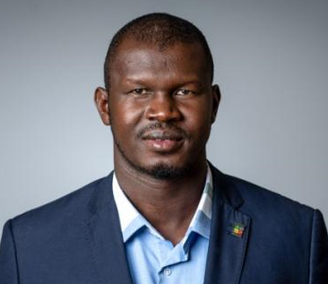

Mr. Moussa is a journalist, with over 13 years’ experience in various community development activities, particularly in citizen engagement and participation programs for young people. Founder of the weekly printed newspaper, *L’Express de Bamako*, and Country Director of the Accountability Lab Mali, he helps with sustainable development through the education of young people in leadership, promotes good governance, honesty and integrity in public service, and runs internship programs on journalism. Some of the participants in his program have obtained key positions in various medias houses in Mali. After his Master’s degree from The University of Bamako and his community service experiences Mr. Moussa has been selected among the 500 Most Valuable African Young Leaders in 2015 as Mandela Washington Fellow of the Young African Leaders Initiative (YALI). He studied Business and Entrepreneurship in Dartmouth College, an Ivy League Institution based in Hanover, New Hampshire (USA). Mr. Moussa worked as Projects Manager in Liberia for the Accountability Lab Liberia, before opening the Accountability Lab office in Mali and he is expanding it now in the rest of Francophone Africa. 2018 Obama Fellow, Mr. Moussa has been also selected among the Draper Hills Fellows to study Democracy and Rule of Law at Stanford University.

**Mandipa Ndlovu**, Visiting Researcher, Centre for African Studies, University of Edinburgh

Ms. Ndlovu is a governance researcher and development policy analyst whose research and consultancy experience extends to working with governments, think tanks, intergovernmental organisations, as well as within academia. Currently, Ms. Ndlovu is a doctoral researcher at Leiden University and a visiting researcher at the University of Edinburgh where her research is focused on urban governance in Africa and its developmental futures. Her broader research interests and publication record cover civil-military relations, sustainable economic development, trauma and memory, post-conflict justice, and gender equity. Ms. Ndlovu is also a Mo Ibrahim Scholar alumna who holds a MSc in Violence, Conflict, and Development from the School of Oriental and African Studies (SOAS) as well as a MPhil in Justice and Transformation from the University of Cape Town (UCT).

**Julie Muia,** Programme Officer**,** African Association for Public Administration and Management

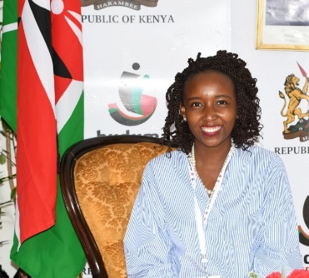Ms. Muia is the officer in charge of programmes at African Association for Public Administration and Management (AAPAM) she is the liaison person between AAPAM and its development partners including UN, AU, APRM, Canadian Bureau of International Development (CBIE) and African governments. With AAPAM she has successfully conducted capacity development programmes in over 20 African countries including Annual Rountable conferences held in Morocco, Zambia, Botswana and Egypt. Ms. Muia holds a bachelor’s degree in Psychology and International Relations from the United States International University- Africa and a master’s degree in international Relations from the United States International University- Africa. She is trained in peacebuilding and conflict resolution from the Kofi Annan International Peacekeeping Training Centre (KAIPTC) in Accra, Ghana. Ms. Muia is a published author of an article on *‘Economic Integration: The Impact of Conflict on Economic Development of Africa’* featured in the African Journal of Public Administration (AJPAM).

**Rishy Bukoree**, Ministry of Foreign Affairs and Trade, Mauritius



Mr. Bukoree works as diplomat for the Government of Mauritius. He currently forms part of the UN Desk at the Ministry of Foreign Affairs, following his posting at the Mauritius Permanent Mission in New York. Prior to joining the Foreign Service, he worked for several years in different capacities within the Civil Service, including at the Ministry of Education, the Ministry of Agro-Industry and Fisheries, and the Government Information Service, Prime Minister's Office. He had previously worked in the communication sector. Mr. Bukoree's academic background include studies in international relations, law and French. His personal interests are reading, painting, swimming, vegetarianism, soccer and family outings.

**Session 8: Special capacity-building segment - monitoring and reporting on SDGs and Agenda 2063**

**Samori A. Okwiya,** CEO, APRM & NEPAD Secretariat, Kenya

**Selamawit Mussie**, SDG Policy Officer, Economic Affairs Department, African Union Commission

Ms. Mussie is SDG Policy Officer of Economic Affairs Department at is African Union Commission. She possesses advanced expertise in International Development and Policy Analysis. Previously, she was Consultant at UNECA from 2008 to 2011. Ms. Mussie holds a B.Sc. in Statistics and a M.Sc. in Population Studies from Addis Ababa University.

**Jean-Yves Adou**, Monitoring and Evaluation Coordinator, APRM, South Africa

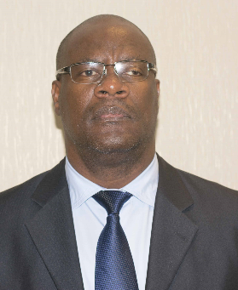

Mr. Adou is currently a Senior Coordinator and Head of the Monitoring and Evaluation Coordination Division at the African Peer Review Mechanism (APRM) Secretariat in Johannesburg. He holds a Master in Statistics Engineering, from the National Higher School of Statistics and Applied Economics (ENSEA) of Côte d’Ivoire and a Masters’ Degree in International Economy and Politics, from Pierre Mendes France University, Grenoble. Mr. Adou also holds several professional certificates in economic coordination, regional integration, project management, macro-economic management, operational planning and project control, public procurement and loan disbursement, Leadership, Diplomacy, and Multinational and Bilateral Negotiation. He has more than fifteen years of international professional experience in the areas of research and statistic, monitoring and evaluation, regional integration, development cooperation, macro-economic and project management. Prior to his position at the African Peer Review Mechanism Secretariat, Mr. Adou has occupied several positions at the African Union Commission in Addis Ababa and at the West Africa Economic and Monetary Union (WAEMU) Commission in Ouagadougou. Several professional achievements and Economic research activities are among Mr Adou’s successes which includes his participation in several APRM Review missions, the conceptualization of the APRM electronic questionnaire and Knowledge Hub, the Study on ‘’Governance mechanism of the implementation of Agenda 2063 and SDGs’’, and the study on ''Alternative sources of financing the AU: Impact of the proposals on the economies of AU Member States'' among others. Mr. Adou also published several articles on Statistics and Development Evaluation in the African Union Commission's Integration Review and the African Development Bank Group’s Magazine eVALUation Matters.

**Eunice Kamwendo,** Director, ECA Sub-Regional Office, Lusaka

**Session 9: Taking CEPA principles to strengthen institutions, policy coherence and governance in the post-COVID-19 era**

**Patrick Spearing,** Secretary of the Committee of Experts on Public Administration, United Nations Department of Economic and Social Affairs

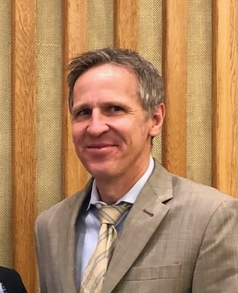

Mr. Spearing is Secretary of the Committee of Experts on Public Administration at UN DESA. Previously, he has served in positions at the United Nations supporting multistakeholder consultations and deliberations pertaining to the Internet and carrying out analytical work on governance and sustainable development. He was also a departmental focal point on governance within the UN System Task Team convened in the lead-up to the 2030 Agenda and has served as a senior information systems officer and editor in the United Nations and non-Governmental sector. Mr. Spearing holds a Master’s degree in Public Administration from Columbia University.

**Louis Meuleman**, Visiting Professor at Public Governance Institute, KU Leuven (Belgium) and Vice-Chair of the UN Committee of Experts on Public Administration

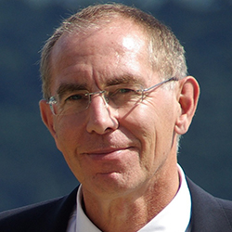

Dr. Meuleman worked at the European Commission in Brussels as coordinator of the Environmental Implementation Review and of the greening of the European Union’s economic and social governance. As a part-time academic, he publishes on sustainability metagovernance and public management. He is visiting professor at the Public Governance Institute of the University of Leuven, in Belgium, and senior fellow at the Center for Governance and Sustainability of the University of Massachusetts, in Boston, United States of America, research associate at the University of Wageningen, in the Netherlands, and member of the editorial board of Impact Assessment and Project Appraisal. He is a member of the International Association for Impact Assessment, the European Sustainable Development Network and the Netherlands Association for Public Management. He has 35 years of public sector management experience, handling subnational, national, regional and international issues, mainly in the fields of the environment and sustainable development, as project, programme and line manager. As director of the TransGov project of the Institute for Advanced Sustainability Studies in Potsdam, Germany, from 2010 to 2011, he produced the report entitled Transgovernance: the Quest for Sustainability Governance and was editor of Transgovernance: Advancing Sustainability Governance (2013). He was director of the Netherlands Advisory Council for Research on Spatial Planning, Nature and Environment, in The Hague, and Chair of the Netherlands Association for Public Management. Mr. Meuleman has authored a number of publications, including his PhD dissertation, Public Management and the Metagovernance of Hierarchies, Networks and Markets (2008) and the practitioners’ case study entitled The Pegasus Principle: Reinventing a Credible Public Sector (2003). He was co-editor of Environmental Governance in Europe (2003). He has published books, book chapters and articles on environmental policy, interactive policymaking, metagovernance, governance of long-term decision-making, cultural diversity and sustainability governance. He has a PhD in public administration and an MSc in environmental biology.

**Ernesto Soria Morales**, Senior Policy Analyst on Policy Coherence for Sustainable Development, Public Governance Directorate, OECD

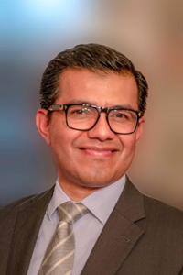Mr. Morales is Senior Policy Analyst at the OECD’s Public Governance Directorate. He leads the team of analysts ad experts responsible for supporting governments in enhancing Policy Coherence for Sustainable Development. He has led the work on the development of the OECD international instrument and standards on policy coherence sustainable development. His recent work has focused on developing analytical tools to support governments in strengthening institutional mechanisms and capacities to enhance and track progress on policy coherence for the implementation of the Sustainable Development Goals (SDGs). In this position, he also helped shape and take forward the OECD Strategy on Development launched in 2012. He joined the OECD in February 2009 as a Senior Policy Analyst on development to support the Heiligendamm-L’Aquila Dialogue Process between the G7 and the five major emerging economies (G5: Brazil, China, India, Mexico, South Africa) where he helped to facilitate political dialogue on common principles for effective development co-operation and triangular co-operation. Prior to joining the OECD, Mr. Soria Morales worked for the Mexican Ministry of Foreign Affairs as policy analyst and advisor in several areas including the Under-secretariat for international cooperation and the Under-secretariat for the United Nations system. He has been a guest lecturer at the Complutense University of Madrid since 2013. From 2002-2005 he was also lecturer in development and international co-operation at the Faculty of Political and Social Sciences of the National Autonomous University of Mexico as well as for the Master’s Programme in Development and International Cooperation at the José María Luis Mora Research Institute in Mexico. Ernesto Soria Morales, graduated in International Relations at the National Autonomous University of Mexico, holds postgraduate studies in development and international cooperation by the Complutense University of Madrid. He is co-author of several OECD reports on policy coherence.

**Jaco du Toit**, Chief of Universal Access to Information Section, Communication and Information Sector, UNESCO

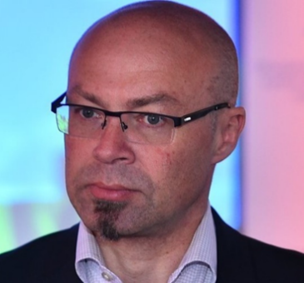Mr. du Toit is Chief of the Universal Access to Information Section at the Communication and Information Sector of UNESCO. He previously held the position of Programme Specialist, providing support to the UNESCO Information for All Programme and serving as regional adviser for UNESCO’s Communication and Information Sector in Eastern Africa, Southern Africa and North Africa. He has an academic background in information sciences, political sciences, information for development, communication and telecommunication and media and international relations. He has worked on projects related to knowledge society development, Right to Information laws, disabilities and Information and Communication Technologies and Information and Communication Technologies in Education.